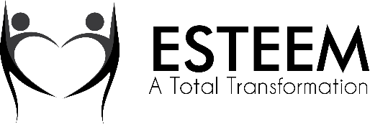
Media Release Form

I grant permission to ESTEEM, A Total Transformation to use my child(ren) image (photographs and/or video) for use in ESTEEM publications including videos, email blasts, recruiting brochures, newsletters, and magazines and to use my child(ren) image in electronic versions of the same publications or on the ESTEEM website or other electronic forms of media.
I hereby waive any right to inspect or approve the finished photographs or electronic matter that may be used in conjunction with them now or in the future, whether that use is known to me or unknown, and I waive any right to royalties or other compensation arising from or related to the use of the image.
_______I am the parent or legal guardian of the below named child. I have read this release before signing below, and I fully understand the contents, meaning and impact of this release. I understand that I am free to address any specific questions regarding this release by submitting those questions in writing prior to signing, and I agree that my failure to do so will be interpreted as a free and knowledgeable acceptance of the terms of this release.
Date: ___________________________

Name (please print): ______________________________________________________________

Address: ________________________________________________________________________

Signature of parent or legal guardian:

________________________________________________

